Batch: A2 Roll No.: 16010122034

Experiment No. 3

TITLE : To study and implement Restoring method of division

AIM : The basis of algorithm is based on paper and pencil approach and the operation involves repetitive shifting with addition and subtraction. So the main aim is to depict the usual process in the form of an algorithm.
______________________________________________________________________
Expected OUTCOME of Experiment: (Mention CO /CO’s attained here)

CO1- Describe and define the structure of a computer with buses structure and detail working
of the arithmetic logic unit and its sub modules
_____________________________________________________________________

Books/ Journals/ Websites referred:

- Carl Hamacher, Zvonko Vranesic and Safwat Zaky, “Computer Organization”, Fifth Edition, TataMcGraw-Hill.
- William Stallings, “Computer Organization and Architecture: Designing for Performance”, Eighth Edition, Pearson.
3. Dr. M. Usha, T. S. Srikanth, “Computer System Architecture and Organization”, First Edition, Wiley-India.
_____________________________________________________________________

Pre Lab/ Prior Concepts:
The Restoring algorithm works with any combination of positive and negative numbers

Flowchart for Restoring of Division:
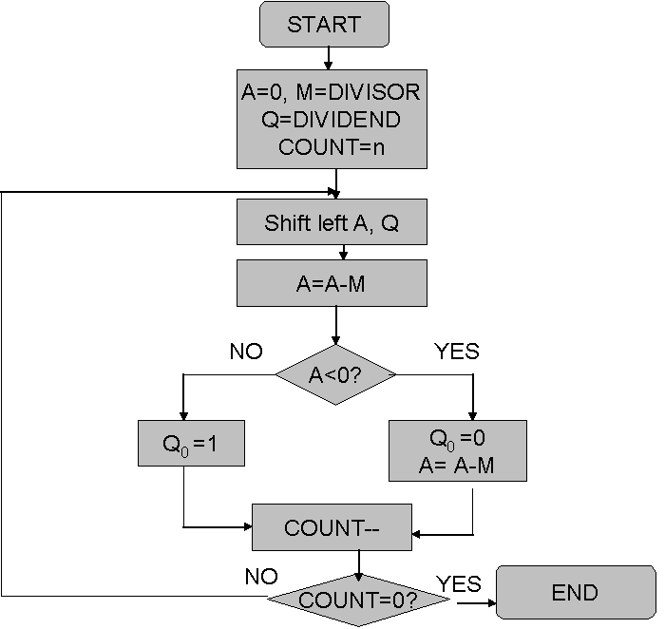
Design Steps:
- Start
- Initialize A=0, M=Divisor, Q=Dividend and count=n (no of bits)
- Left shift A, Q
- If MSB of A and M are same
- Then A=A-M
- Else A=A+M
- If MSB of previous A and present A are same
- Q₀=0 & store present A
- Else Q₀=0 & restore previous A
- Decrement count.
- If count=0 go to 11
- Else go to 3
- STOP

CODE

#include <stdio.h>
#include <stdlib.h>

void restoring_division(int * m, int * q, int size);

int main()
{
int m[] = {0, 0, 1, 0, 0};
int q[] = {0, 1, 0, 0, 1};

int *pm = m;
int *pq = q;
restoring_division(pm, pq, 5);

return 0;
}

void restoring_division(int * m, int * q, int size){
int * a = (int *)calloc(size, sizeof(int));

printf("m:");
for (int i = 0; i < size; i++)
printf("%d", m[i]);
printf("\ta: ");
for (int i = 0; i < size; i++)
printf("%d", a[i]);
printf("\tq: ");
for (int i = 0; i < size; i++)
printf("%d", q[i]);

// TWOS COMP
int * mcomp = (int *)calloc(size, sizeof(int));
int found_one = 0;
for(int j = 1; j <= size; j++) {
int place = size - j;
int digit = m[place];
if (found_one == 1) {
if(digit == 1)
mcomp[place] = 0;
else
mcomp[place] = 1;
continue;
}
mcomp[place] = m[place];
if (m[place] == 1)
found_one = 1;
}

printf("\nM 2's COMP:\t");
for (int i = 0; i < size; i++)
printf("%d", mcomp[i]);
printf("\n");

for (int i = 0; i < size; i++){
printf("\n------------- CYCLE %d -----------\n", i + 1);
for (int i = 0; i < size; i++)
printf("%d", a[i]);
printf("\t");
for (int i = 0; i < size; i++)
printf("%d", q[i]);
printf("\n");

// LEFT SHIFT
for (int j = 1; j < size; j++){
a[j - 1] = a[j];
}
a[size - 1] = q[0];
for (int j = 1; j < size; j++){
q[j - 1] = q[j];
}

printf("After Left Shift: ");
for (int i = 0; i < size; i++)
printf("%d", a[i]);
printf("\t");
for (int i = 0; i < size; i++)
printf("%d", q[i]);
printf("\n");

// A -> A + (-M)
int c = 0;
for (int j = 1; j <= size; j++){
int p = size - j;
int sum = mcomp[size - j] + a[size - j] + c;
if(sum == 3){
a[size - j] = 1;
c = 1;
}
else if (sum == 2){
a[size - j] = 0;
c = 1;
}
else if (sum == 1){
a[size - j] = 1;
c = 0;
}
else {
a[size - j] = 0;
c = 0;
}
}
printf("After A -> A + (-M): ");
for (int i = 0; i < size; i++)
printf("%d", a[i]);
printf("\t");
for (int i = 0; i < size; i++)
printf("%d", q[i]);
printf("\n");

if (a[0] == 1){
q[size - 1] = 0;

// A -> A + M
int c = 0;
for (int j = 1; j <= size; j++){
int p = size - j;
int sum = m[size - j] + a[size - j] + c;
if(sum == 3){
a[size - j] = 1;
c = 1;
}
else if (sum == 2){
a[size - j] = 0;
c = 1;
}
else if (sum == 1){
a[size - j] = 1;
c = 0;
}
else {
a[size - j] = 0;
c = 0;
}
}

}
else{
q[size - 1] = 1;
}

// PRINTING CYCLE
for (int i = 0; i < size; i++)
printf("%d", a[i]);
printf("\t");
for (int i = 0; i < size; i++)
printf("%d", q[i]);

}
}

OUTPUT

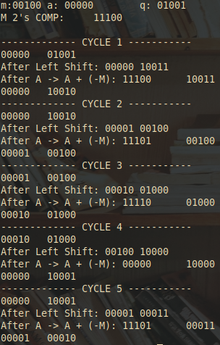Example:- (Handwritten solved problems needs to be uploaded)

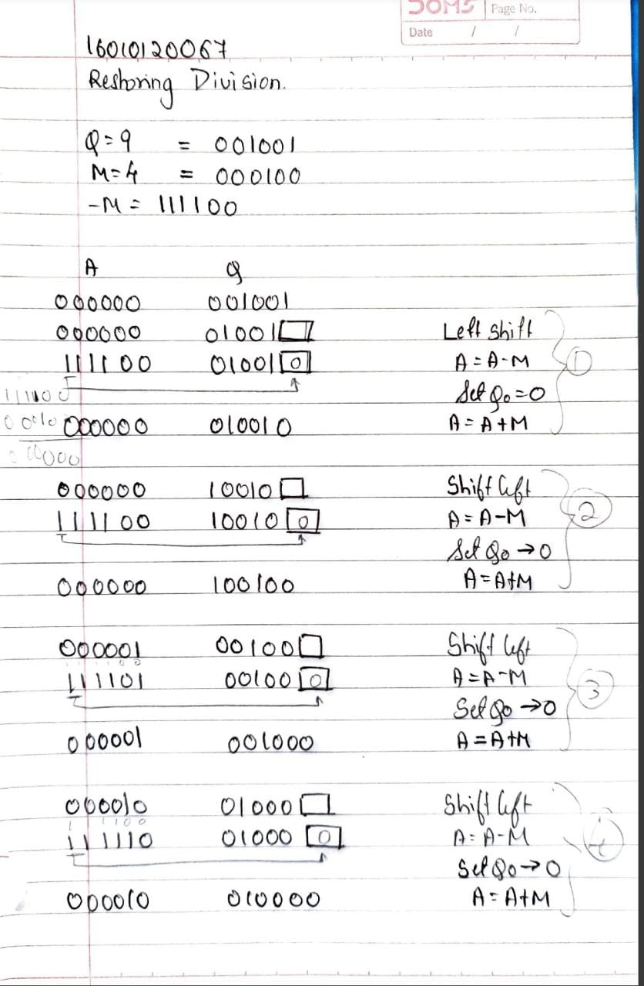

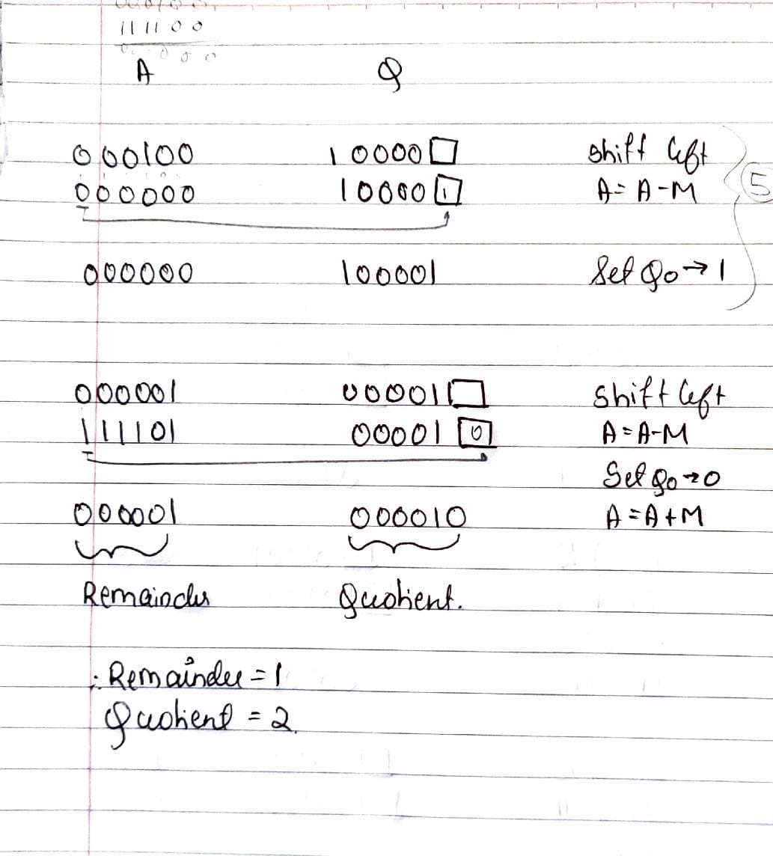

Conclusion: The concept of restoring method of division was used to divide two binary numbers and verified.
Post Lab Descriptive Questions
- What are the advantages of restoring division over non restoring division?
ANS:
- Simplicity of Quotient Correction: In restoring division, the quotient correction step is simpler compared to non-restoring division. In restoring division, the quotient is corrected by simply adding the divisor to the remainder when a subtraction borrow occurs. This correction is straightforward and doesn't involve complex logic.

- Predictable Correction: Restoring division has a more predictable correction process. When a borrow occurs during the subtraction step, it's guaranteed that the correction will involve adding the divisor to the remainder. This straightforward correction behavior makes the algorithm easier to implement and understand.

- Easier Hardware Implementation: The hardware implementation of restoring division is generally simpler compared to non-restoring division. This is because the correction step involves adding the divisor to the remainder, which is a simpler operation than the complex adjustments required in non-restoring division.

- Single Cycle Throughput: Restoring division can potentially achieve a single cycle throughput (one division result per clock cycle) in some hardware implementations, which is beneficial for high-performance applications.

- Regular Division Process: Restoring division follows a more regular division process. The steps of subtraction, shifting, and correction are consistently repeated until the division is complete. This regularity can make it easier to analyze and optimize the algorithm.

- Less Complex Control Logic: The control logic for restoring division is generally less complex compared to non-restoring division, which often involves additional logic for conditionally shifting and adjusting the remainder.

Date: ___________________ Signature of faculty in-charge :

